What is electricity?
A form of __________________, measured in J_________________
Energy = the ability to do ___________________
Static electricity = electric charges are _____________ ______________________________
Electric current = __________________ charges (usually ________________)
Electrons will flow towards a ________________________ charge
By definition, we say that “conventional current” flows from ___________________ to ____________________________________
Electric circuits can be divided into two types:
AC = _________________ current
DC = __________________ current

Comparing an electric circuit with a water “circuit”
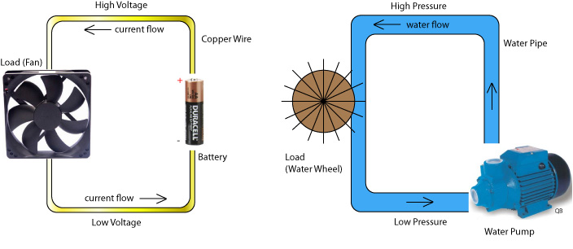
Electric circuit | Water circuit
Current | Flow rate
Voltage | Pressure
Load (fan) | Load (water wheel)
Resistance | Narrow pipe

Drawing electric circuit diagrams
To keep things NEAT, we use special symbols (and STRAIGHT LINES) to draw electric circuit diagrams.

