**Topic 19.1 – Electrochemical cells**

**Voltaic cell** – convert chemical energy to electrical energy

**EMF (electromotive force)** = maximum voltage that can be delivered by the cell



**Cell potential** = potential difference between the anode and cathode when the cell is operating



**Standard cell potential** = cell potential under standard conditions (298K, 100kPa for gases, 1 mol dm-3 for aqueous reactants)



To determine the standard cell potential:



E°cathode – E°anode



Spontaneous (galvanic cell) 🡪E°cell is positive



Non-spontaneous (electrolytic cell) 🡪 E°cell is negative







**Calculating E°cell:**

Determine reaction at cathode (reduction – forward reaction on table) – find voltage

Determine reaction at anode (oxidation – reverse reaction on table) – subtract this voltage from cathode voltage

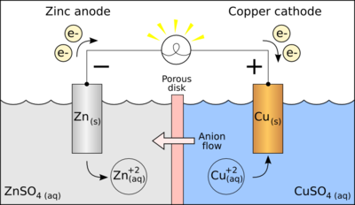

Calculate the standard cell potential of the voltaic cell shown here



Two half-cells, one containing Fe2+ and Fe and the other containing Ag+ and Ag, are connnected to form a voltaic cell. Use a Standard Reduction Potential table to determine the direction of spontaneous reaction and the value for E°cell. Give equations for the half reactions.



Use a Standard Reduction Potential table to determine the E°cell value for the spontaneous reaction of each pair of half-cells listed below:



a) Ag ===> Ag+ + 1e- ; Fe2+ + 2e- ===> Fe



b) Mg ===> Mg2+ + 2e- ; Sn2+ + 2e- ===> Sn

c) Li ===> Li+ + 1e- ; Mn2+ + 2e- ===> Mn

d) Cr ===> Cr3+ + 3e- ; Hg2+ + 2e- ===> Hg;

e) Ni ===> Ni2+ + 2e- ; Cu2+ + 2e- ===> Cu

**Standard Hydrogen electrode:**

Because we cannot measure absolute potential, only potential difference, we must define a zero. In electrochemical cell terms, this zero is the standard hydrogen electrode, consisting of an inert platinum electrode in contact with 1 mol dm-3 hydrogen ions and hydrogen gas at 100 kPa.

