**Bonding – HL topics**

1. **Formal charge**

In determining the preferred Lewis structure from amongst several candidates that look possible on paper, one should choose the structure that results in the lowest formal charge (closest to zero for all atoms). To calculate formal charge:

FC = number of valence electrons- ½ number of bonding electrons – number of non-bonding electrons

Given that the formula for formaldehyde is CH2O, one could draw three Lewis structures starting with the skeletons:



H H



H—C—O—H H—C—O C—O—H



Complete the structures by adding double bonds and valence electrons as needed and determine which is the preferred structure based on minimizing formal charge.



1. **Special cases of resonance**

Resonance as a way of depicting a bonding mode that is in between two (or more) extremes has been explored already. In practice, structures that have resonance display unusual stability compared to structures without resonance. Some examples you should be familiar with are:

Carbonate anion (CO32-)



Ozone (O3)



Benzene (C6H6)



Benzene is the simplest member of a family of organic compounds known as aromatic. Aromatic compounds are very stable because of resonance. You have probably heard of some of these compounds.

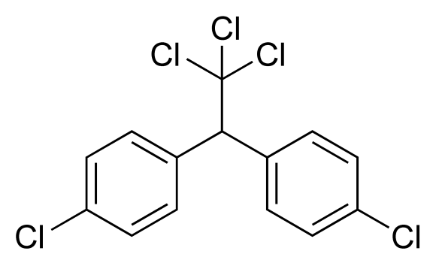



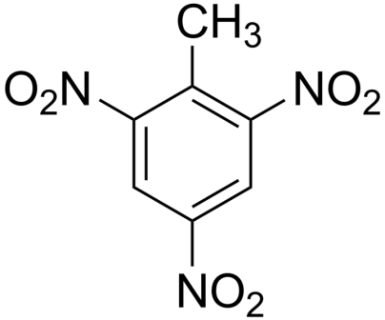



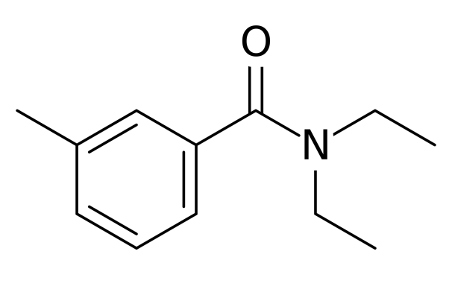



1. **Sigma (σ) and pi (π) bonds.**



Sigma bonds result from head on overlapping of two atomic orbitals.



Example: H2



* Always the first bond formed – i.e. if there is a single bond, it is a sigma bond
* Sigma bonds are symmetrical about the intermolecular axis



Pi bonds result from the sideways interaction of two orbitals



The additional electrons shared in double and triple bonds are shared through pi bonds.

Example: O2, N2



Due to the nature of pi bonds, there is NO FREE ROTATION about a pi bond. What are the implications of this?

1. **Hybridization**

* While VSEPR allows us to accurately predict the observed shapes of molecules, it does not take into account what we know about atomic orbitals (s, p, d, and f – remember those?)
* The trigonal planar arrangement, for example, cannot be explained by bonding using any combination of s and p orbitals, so what do we do?
* We employ a useful mathematical device called orbital hybridization
* Orbital hybridization results from the mixing of atomic orbitals to form the same number of new equivalent hybrid orbitals that can have the same mean energy as the contributing atomic orbitals

If you’re having trouble with that last statement, consider this:



Complete the table below:

|  |  |  |  |
| --- | --- | --- | --- |
| # of electron domains | Orbitals involved | Hydbrid orbital created | Shape |
| 2 | s, 1 p | sp | linear |
| 3 |  |  |  |
| 4 |  |  |  |
| 5 |  |  |  |
| 6 |  |  |  |



Using your knowledge of bonding, explain the difference in bonding between ethane (C2H6), ethene (C2H4) and ethyne (C2H2). In your explanation you should explore the shape of the molecule, types of bonds, and orbital hybridization.