The Sub-Atomic Particle – J.J. Thomson
Name:
Date:
“Plum Pudding Model”

Preceded by Dalton’s “Billiard Ball” – Succeeded by Rutherford’s Nuclear Model
Sir Joseph John Thomson (a British physicist), throughout the 1880s and 1890s led experiments with Rays. Through these experimentations, he discovered, in 1897 that the cause of electrical energy is a particle smaller than what was previously thought to be the smallest particle in existence, the atom. This smaller particle is called subatomic (smaller than an atom) or an . Prior to this discovery, atoms were thought to be or billiard ball like. With this new discovery, was completely revisited. In 1904, Thomson presented his new theory of the model of the atom: the Plum Pudding Model. In this model, Thomson theorized that the bulk of the atom is a mass of positive charge while electrons are uniformly scattered throughout. While the Plum Pudding Model is no longer accepted as accurate, it helps to mathematically explain the of atoms: a balance of charges, an equal number of and .
Characteristics of Plum Pudding Model
- Positively charged, dispersed mass (pudding)
- Electrons uniformly distributed throughout cloud (plums)
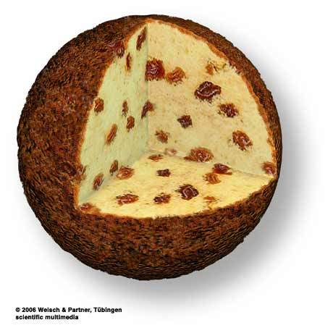
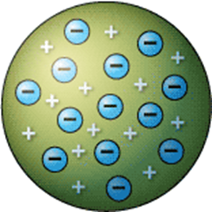Thomson’s Model
Green = positively charged mass (pudding)
Blue = electrons (subatomic particles/ plums)

Thomson’s Model Revised: Plum Pudding
Word Bank: protons, neutron, avocado, neutrality, Rutherford, homogenous, electron, electrons, Cathode, anode, atomic theory
Questions:
- Compare Thomson’s atomic model to that of plum pudding. What other objects can be accurately compared to his model?

- The plum pudding model is described as an inverted version of the currently accepted model. In what ways are the two models inversions of each other?

- Sketch a Plum Pudding Model of the following elements;
  - Hydrogen

  - Carbon

  - Oxygen

- What are the faults in Thomson’s model?

- Describe how Thomson’s model is a stepping stone for future atomic structures.

Word Bank Answers: Cathode, electron, atomic theory, neutrality, protons, electrons

