**Static Electricity**

Static charges are electric charges at ____________________

Static charge results from an object having an unequal number of ___________________ and ___________________________.

* Because electrons are located at the outside of atoms, they are easier to lose than protons.
* Objects that are lower down the electrostatic series (pg. 276 in your textbook) tend to lose electrons to objects that are higher up in the table.
* An object that has lost electrons will have a _______________________ charge
* An object that has gained electrons will have a ______________________ charge
* The law of electric charges states that like charges _______________________ and unlike charges _______________________.

**Transferring static charge  
Friction** – charges are transferred when objects are rubbed together

C:\Users\cxvanmaarseveen802\AppData\Local\Microsoft\Windows\Temporary Internet Files\Content.IE5\6KC3YCWK\MC900326124[1].wmf

**Conduction** – charges are transferred when objects touch

**Induction** – objects DO NOT TOUCH, but the electrons within the objects change their position

**Insulators and Conductors**

Insulators are materials in which electrons are not free to move. Static electric charges are more likely to build up in good insulators. Find the table in your textbook on pg. 282 and list FOUR good insulators

Conductors allow electrons to flow freely. Semiconductors/insulators such as germanium allow electrons to flow, but offer some resistance.

**Van de Graaff generator**

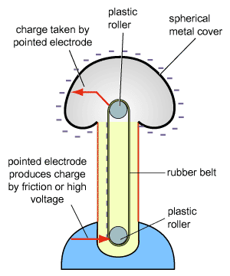What happens to your hair when you touch a Van de Graaff generator? Why?

What happens to bubbles blown near a Van de Graaff generator?

Coulomb’s Law states: *The strength of the electric force increases with increasing electric charges and decreases with increasing distance.*

This means that objects with more/less charge will have a stronger electric force between them and as objects move further apart, the electric force between them will increase/decrease

CYU

Pg. 278 #4,5,8,9, 11, 12

Pg. 281 # 4, 6, 8, 9

Pg. 284 # 1-6

Pg. 287 #1, 3, 5, 7, 8