**Chapter 6 – The elements - summary**

**Ancient chemistry**

Described properties of matter in terms of four “elements”



* A__________
* E__________
* F__________
* W____________

Ancient chemistry was closely tied to alchemy, and attempted to turn metals into gold.

Modern chemistry began when scientists began to do more rigorous experiments.

* Robert Boyle encouraged scientists to be skeptical
* New elements were discovered by experimentation and observation
* If a substance was discovered that could not be broken down, it was called an __________________

**Elements and compounds**

* Elements are made up of only one type of atom
* All elements are shown on the periodic table
* Elements are represented by a one or two letter abbreviation
  + Examples: Fe, Au, N, O
* Compounds are made up of two or more elements chemically combined together
  + Examples:
    - Water – H2O
    - Ammonia – NH3
    - Sodium chloride - NaCl
* The formula for a compound shows both what type of atoms make up the compound and how many of each are present
  + How many and what type of atoms are present in each of the compounds named above?

**Types of elements**

* Metals – share properties of lustre (shininess), heat and electrical conductivity, malleability, and ductility
  + Examples of metals:
  + Where are metals found on the periodic table?
* Non-metals – lack the properties of metals
  + Examples of non-metals:
  + Where are non-metals found on the periodic table?
* Metalloids/semi-metals – have some properties of metals and some properties of non-metals
  + Examples of metalloids:
  + Where are metalloids found on the periodic table?

*Periodic table*

* Groups elements with similar properties together
* Elements are arranged in order of their mass
* Elements in a column (family) have similar properties
* Mendeleev arranged the elements in a table based on their masses and properties. This allowed him to predict the properties of elements that had not yet been isolated

**Chapter 7 - Atomic Theory**

7.1-7.2 Development of a modern Atomic Theory

|  |  |  |
| --- | --- | --- |
| **Experimental evidence** | **People involved** | **Key points of theory** |
| Some matter cannot be broken down into simpler substances | John Dalton (England) |  |
| Cathode rays can be deflected by electrical and magnetic fields | J.J. Thomson (England) |  |
| Gold foil experiment produced unexpected results. Some particles were deflected at odd angles, and others passed through unaffected | Ernest Rutherford (Canada) |  |
| Different elements emit different colours (wavelengths) of light when they are excited by electricity | Niels Bohr (Denmark) |  |

Questions based on the video:

1. If an orange was blown up to the size of the earth, how big would the atoms be?
2. What did Thomson call his model of the atom? What more common American/Canadian analogy could we use?
3. If the atom was blown up to the size of a football stadium, how big would the nucleus be?
4. If the mass of the atom is mainly in the nucleus, the nucleus must be very dense. What mass would 1 cubic centimeter of nuclear material have? How many small cars would that be equal to?

**Standard Atomic Notation**

* Atoms are made up of three different types of subatomic particles
  + The nucleus contains positive ___________________ and neutral ________________________
  + Negatively charged ___________________________ are found outside the nucleus. The electrons are much smaller than the protons and neutrons.
* Atomic number refers to the number of __________________ in the nucleus of an atom
* Each element has a different atomic number
* The total number of protons + neutrons in the nucleus gives us the ___________________ number of an atom
* In a neutral atom, the number of _______________________ is equal to the number of protons (so the overall charge is zero)
* If an atom has gained or lost electrons, it is called an __________.
* Standard notation gives information about the atomic number, mass number, chemical symbol, and charge of a particle.
* For example, the symbol . . . .

Complete the following table

|  |  |  |  |  |  |  |
| --- | --- | --- | --- | --- | --- | --- |
| **Symbol** | **Mass number** | **Atomic number** | **#p** | **#n** | **#e** | **charge** |
| 23Na |  |  |  |  |  | 0 |
|  | 23 | 11 |  |  | 10 |  |
| C | 12 |  |  |  |  |  |
|  |  |  | 6 | 8 | 6 |  |
| H | 1 |  |  | 0 |  |  |

**7.3 – The Modern Periodic Table**

Organization of the periodic table

Refer to pg. 214 of your textbook

Where on the periodic table are metals found? ______________________

Non-metals? ____________________________

Metalloids? ___________________________

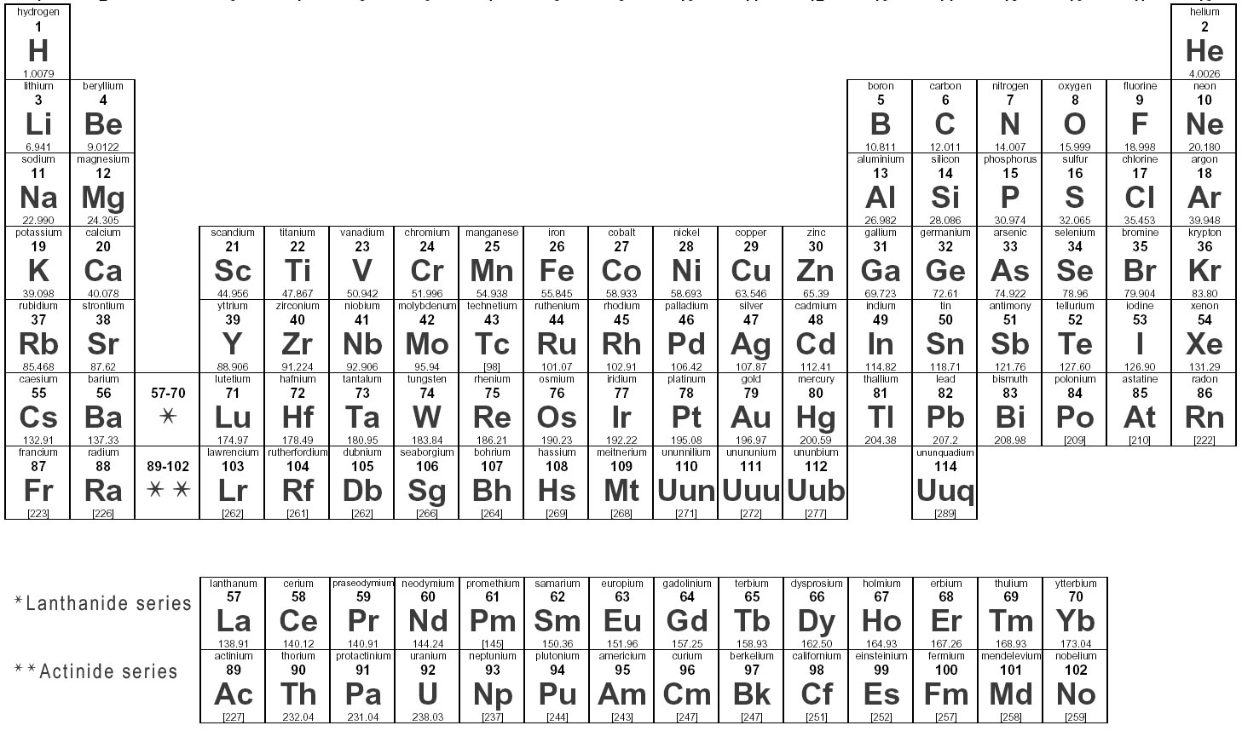

If you put the Lanthanide and Actinide series in their proper places, it would look like this

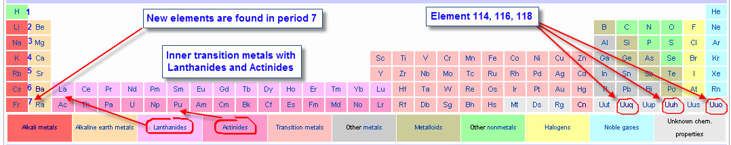

**Information in the periodic table** – if you look at the square for each element, you will find two important numbers

Number at the top = atomic number

Number at the bottom = atomic mass

**Why are the atomic masses not always whole numbers?**

Some elements have different forms (known as isotopes) that have different numbers of ________________. Even though the number of protons is the same (because they’re the same element), different numbers of neutrons mean different mass numbers. The atomic mass is the average of the mass numbers of all the isotopes of the element. Because some isotopes are much more common than others, the atomic mass might be very close to the mass of one isotope. A good example is carbon. The atomic mass is very close to 12, because most carbon atoms are carbon-12 (they have 6 protons and ___ neutrons). Only a few are carbon-13 (with ____ neutrons) or carbon-14 (with ____ neutrons)

**What about ions?**



Ions are formed when an atom loses or gains electrons (it does this to become more stable). The charge on an ion is found by taking #protons-#electrons. A negative number means there are more electrons than protons and the ion has a negative charge. A positive number means there are more protons than electrons and the ion has a positive charge.

For example:

A sodium ion has 11 protons and 10 electrons. What is its charge?

An oxygen ion has a charge of -2 and 8 protons. How many electrons are there in an oxygen ion?

A certain ion has 4 protons and 2 electrons. What ion is this?

**7.4 – Using the Bohr Theory**

Recall – according to Bohr’s theory of the atom, electrons are located in energy levels or “shells” around the nucleus.

* Each shell can hold a certain number of electrons.
* The first shell can hold 2 electrons while the second and third shell can hold 8 each.
* Atoms are stable when their outer electron shell is completely full (or completely empty)
* Atoms can gain or lose electrons from their outer shell to form ions

Drawing Bohr diagrams:

Bohr theory and . . . .

Reactivity

Elements are very reactive when they have nearly full or nearly empty valence electron shells? Which groups are these? Why are these groups of elements reactive?



Which group of elements is non-reactive? Why?

**Ionic bonding:**

When a metal reacts with a non-metal, an ______________________ compound is formed

An ionic bond involves the ___________________________ of electrons.

The metal ________________________ one or more electrons, becoming positively charged



The non-metal ________________________ one or more electrons, becoming negatively charged



The bond is held together by the attraction between the positive and negative ions.



**Molecular bonding:**

Molecular (also called covalent) bonds are formed when two or more atoms ________________ electrons

