The Nuclear Model (also known as the Rutherford Atomic Model)
-Created by Ernest Rutherford (British physicist) in 1911 at the physical laboratories of the University of Manchester. Ernest was awarded the Nobel Prize for research regarding disintegration of elements and the chemistry of radioactive substances in 1908.
-Based on the results of the Gold Foil Experiment (also known as the Rutherford Experiment/ the Geiger-Marsden Experiment)
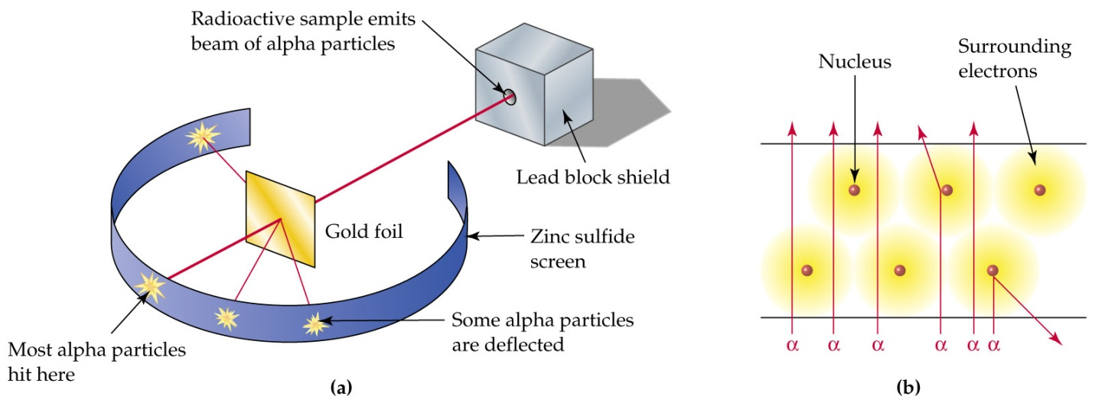
http://1.bp.blogspot.com/_Da4JKu_7EEo/TK0h0cSSMLI/AAAAAAAAAB8/Fws_fPoN5o8/s1600/diagram.jpg
- Consisted of firing radioactive alpha particles (with + charge) through thin metal foil- Ernest Rutherford was able to detect these particles by using a screen that was coated with zinc sulfide.
- Most alpha particles passed straight through the gold foil, some were deflected and some were scattered back at large angles.
Passed through= implied atoms mostly made up of open space
Deflected= interactions with other positively charged particles in atom
Scattered Back at Large Angles= such strong repulsion could only be explained by a relatively heavy, positively charged target particle (proposed nucleus)
- Collision showed that 1 in approximately 8000 particles were deflected, resulting in the theory that the atom is made up of mostly empty space.
- From these results, Ernest Rutherford created his hypothesis in 1911, which stated:

An atom consists of: a positively charged nucleus where nearly all of the mass is concentrated (nucleus is a relatively small size compared to the rest of the atom) that electrons (very little mass and negatively charged) orbit
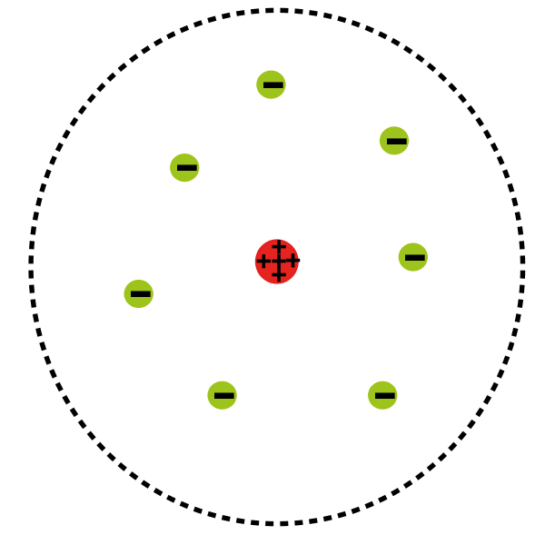

1. Who created the Nuclear Model?
2. What was the name of the experiment that resulted in the Nuclear Model?
3. Describe the experiment.
4. What were the conclusions of the experiment? How did the results lead to the formulation of the Nuclear Model?
5. Explain what an atom is comprised on based on the Nuclear Model.
The Nuclear Model

