Notes Page
Jaimie, Felix, Vincent, Adam
Born August 30th 1871 Nelson New Zealand
Died October 19 1937 Cambridge
He discovered that there is a concentrated positive charged in the middle of atom.
His thesis was entitled magnetization of iron by high frequency discharges. Alpha particles
Discovered that most of an atom’s mass is located in the nucleus
Invented a detector for electro-magnetic wave.
Worked with someone else on the behaviour of ions in gases
The atom’s electron doesn’t affect the alpha particle
Collaborated with Frederick Soddy on creating disintegration theory: A theory of radioactivity which regards radioactive phenomena as atomic-not molecular processes
There were large amount of experimental evidence
Bohr and Rutherford worked together in 1912, and Bohr adapted Rutherford’s nuclear structure to Max Planck’s quantum theory
Together with HG Moseley he used cathode rays to bombard atoms of various elements and showed that the inner structures correspond with a group of lines which characterize the elements.
In 1919 he became the first person to transmute one element to another for example Nitrogen to Hydrogen through nuclear reaction involving the shooting of Alpha particle
¹⁴ ₇ N -> ⁴ ₂He + ⁴ ₂He + ⁴ ₂He + ² ₁ H
Each element can assigned into an atomic number
Discovered Alpha and Beta ray
Alpha ray = Helium Nuclei
When alpha particles are fired into gas atoms, a few are violently deflected, which means that there is a dense, positively charged central region, aka the nucleus, containing most of the mass

Questions

- How did he discover the nucleus?
- What is an alpha particle?
- What country was he born in?
- What element did he turn into hydrogen through nuclear reaction?
- What did kind of waves did the detector he made identify?

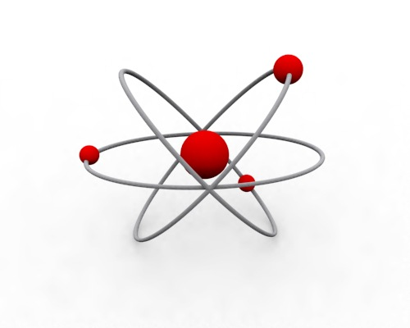

References:
www.nobelprize.org
www.chemheritage.org
www.rutherford.org.nz

