Reflection – Mirrors
When light encounters a surface, some of it is reflected
Look up and add to the diagram: incident ray, reflected ray, normal, angle of incidence, angle of reflection

Why can we not see our reflection in any surface?
It’s not that the law of reflection is sometimes ignored. It always holds, no matter the orientation of the surface. Not all surfaces are microscopically smooth.
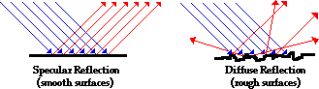
Ray diagrams – we can represent the formation of images by drawing two rays of light coming from the object, reflecting off the mirror, and heading towards the observer. Any time a light ray encounters a mirror, the law of reflection is observed.

Describing the image – remember the acronym SALT
Size
Attitude
Location
Type

Images formed in a plane mirror are:

What if the reflective surface is curved?

Law of reflection still applies, but at each point along the curved surface, the normal has a different orientation. What happens to the light?
Convex mirror
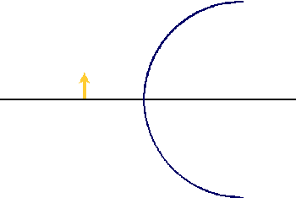

Concave mirror
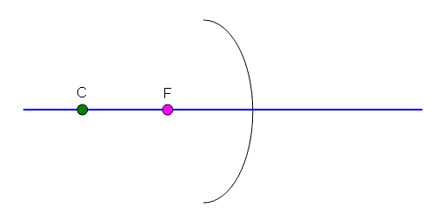
Ray diagrams for curved mirrors:
- Draw one ray from top of object parallel to principal axis
- Draw one ray from top of object through

