Quantum Mechanics

- In 1927 a German physicist stated that the position and velocity of an electron cannot both be known at the same time.
- Electrons are not located in discrete orbits, as hypothesized in the Bohr model, but instead occupy a hazier region, called an orbital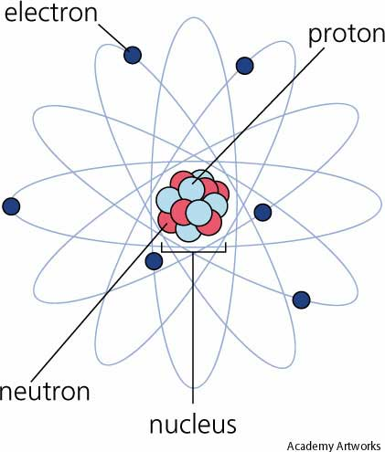
- An orbital indicates a probable location of the electrons in an atom instead of a definite path that they follow.
- The probable location of the electrons in an orbital is described by a series of numbers called quantum numbers.
- The quantum model of the atom uses four quantum numbers to describe the arrangement of electrons in an atom. This arrangement is known as the electron configuration.

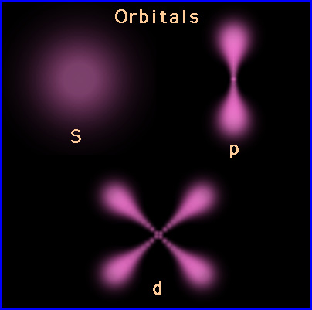

questions
#1: How many possible energy levels are there for an atom?

#2: The _____________ arrangement uses _____ quantum numbers.

#3: Name two of the three things Bohrs model does not account for.

#4: What does 'p' stand for?

#5: Electrions can act as particales and ______.

