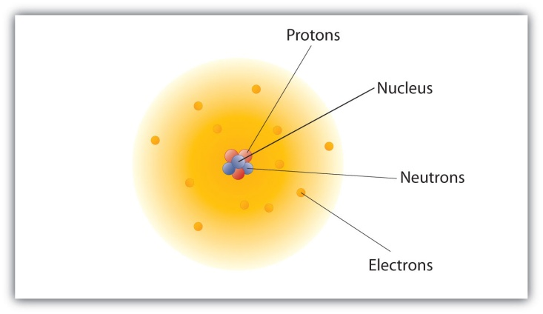
The Modern Atomic Model The modern atomic model is not the Bohr model. In actuality the Bohr model was replaced in the 1920’s by the Quantum Mechanical Model. The developments of the Quantum Mechanical Model from then to now sums out our modern atomic model
What is the Current Quantum Mechanical Model? It is basically that the electron’s location can vary depending on its energy level- higher energy when it is farther away and more loosely connected to the nucleus
The QM model depicts a gas like cloud of negative charge around the atom that has specific densities which vary from place to place. The denser a particular part of the cloud, the more probable that an electron would be in that area
Modern Atomic Model
Quantum Mechanics is a branch of physics that deals with physics in microscopic scales
What is the Difference between the Bohr Model and the Quantum Mechanical Model?
While both the Bohr model and the quantum mechanical model place the nucleus at the center just about everything else is about them is different
In the QM model the electron does not have a direction or specific orbit but rather an orbital which is the area with which the electron is most likely to be
In the Bohr model electrons follows strict orbits that revolve around the nucleus like planets around the sun
Orbits and orbital’s are not the same shape and the electron’s location cannot be predicted in an orbital
The Bohr model was introduced by Niels Bohr while the QM model was introduced by Werner Heisenburg
The QM model uses complex mathematics to explain the location of the electron
Werner Heisenberg proposed the uncertainty principle in 1920’s regarding the QM model which states that it is impossible to calculate for both the momentum and location of the electron at any given point in time
Some Terminology for Quantum Mechanical Model
Waveform - A representation of the shape of a wave. Ex. The blur of a moving guitar string
Nodes - The locations in a waveform where the intensity of the wave is always zero. Ex the ends of a guitar string that don’t move
Orbitals - The allowed waveforms for the electron. This term can also be defined as a volume that contains a high percentage of the electron charge or as a volume within which an electron has a high probability of being found.
Principal energy level or shell - A collection of orbitals that have the same potential energy for a hydrogen atom, except for the first (lowest) principal energy level, which contains only one orbital (1s). For example, the 2s and 2p orbitals are in the second principal energy level.
Ground state - The condition of an atom whose electrons are in the orbitals that give it the lowest possible potential energy.
Excited state - The condition of an atom that has at least one of its electrons in orbitals that do not represent the lowest possible potential energy.
Sublevel or Subshell - One or more orbitals that have the same potential energy, the same size, and the same shape. For example, the second principal energy level contains a 2s sublevel (with one spherical orbital) and a 2p sublevel (with three dumbbell-shaped orbitals).
Orbital diagram - A drawing that uses lines or squares to show the distribution of electrons in orbitals and arrows to show the relative spin of each electron.
Electron configuration - A description of the complete distribution of an element’s electrons in atomic orbitals. Although a configuration can be described either with an orbital diagram or with its shorthand notation
Questions
- Where in the Quantum Mechanical model is the electron most likely found?
- What are the similarities between the Quantum Mechanical model and the Bohr model?
- What is Quantum Mechanics?
- When was the Quantum Mechanical Model introduced?
- Who were two scientists that were key in developing the early Quantum Mechanical Model?

