**Optics – The branch of physics dealing with the behaviour and properties of light**

**Things to remember:**

* Although we have discussed the nature of light and its ability to behave as a wave or particle, we will not generally need to worry about this in geometric optics
* We will treat light as a collection of rays which travel in straight lines until they encounter a surface
* Although we will be looking at visible light, remember that visible light is only a small part of the EM spectrum and other EM waves can exhibit similar behaviours.

How do we see things?

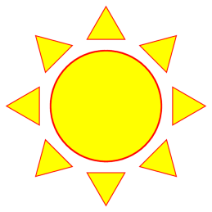 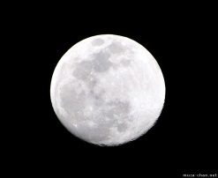

Can we see through things?

Transparent Translucent Opaque

Shadows and eclipses:

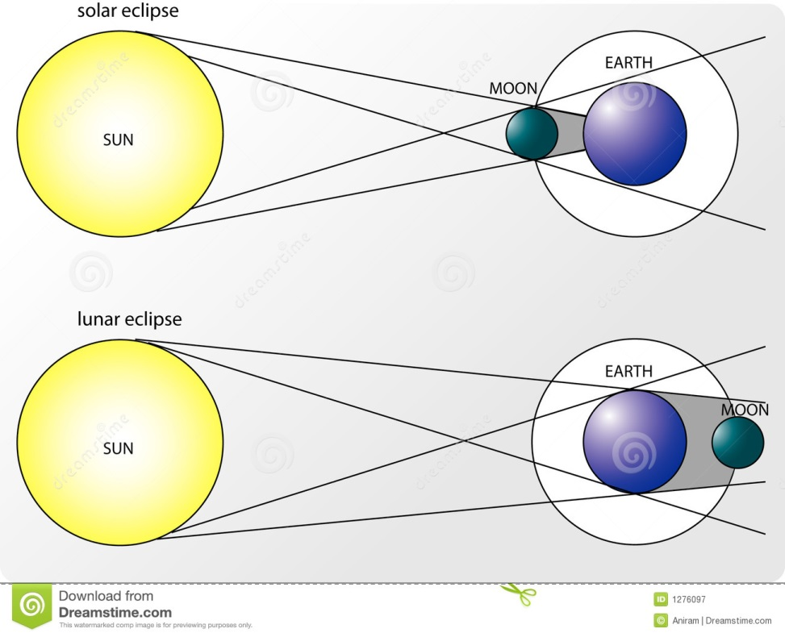

**Colours -**

In the 17th century, Isaac Newton used a prism to produce a spectrum from white light

What are the primary colours of light?

How do we see objects as coloured?

Red shift (the Doppler effect as applied to light)

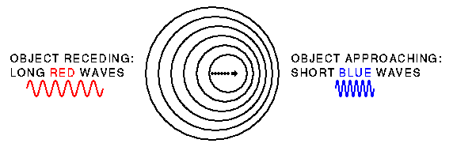

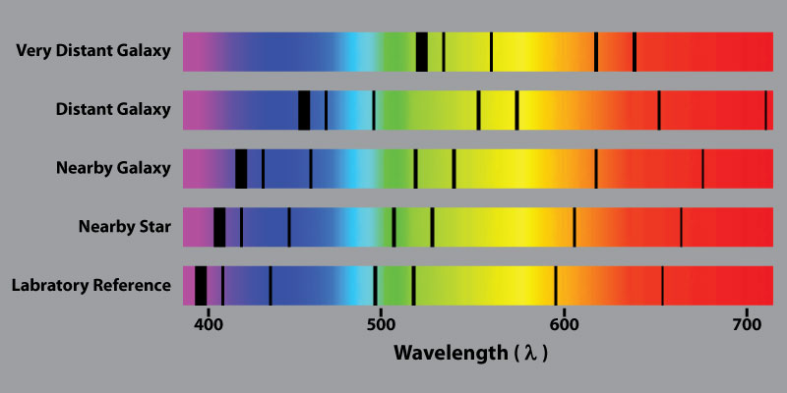

**Images with a pinhole**

What is an image?

How is an image formed?



Can you see the similar triangles? Using this simple mathematical relationship we can calculate a missing value given the other three

hi/ho = di/do where hi is ________________________ho is ______________________

di is _______________________do is _______________________

A student wants to use a pinhole camera to take a picture of a 15m tall tree. If the camera is 35cm long and the photographic paper is 20cm tall, how far away from the tree should the student position the camera to take the picture?

Estimated Time: 18–22 hours By the end of this course, students will understand reflection and refraction of light and its wave nature. Vocabulary amplitude, angle of incidence, angle of reflection, centre and radius of curvature, critical angle, diffraction, Doppler shift, focal length, focal point, frequency, image and object distance, incident ray, index of refraction, interference (superposition principle), normal, period, phase, polarization, principal axis, reflected ray, reflection, refraction, total internal reflection, wavelength, wave speed Knowledge • wave properties • universal wave equation • wave phenomena and conditions • visible light portion of the electromagnetic spectrum • the law of reflection • images produced by mirrors (plane, converging, and diverging) • curved mirrors (concave or convex) • focal length of a concave mirror • Snell’s law • lens (convex or concave) • images produced by converging and diverging lenses • focal length of a convex lens Skills and Attitudes • conduct appropriate experiments • systematically gather and organize data from experiments • produce and interpret graphs (e.g., slope and intercept) • verify relationships (e.g., linear, inverse, square, and inverse square) between variables • apply models (e.g., physics formulae, diagrams, graphs) to solve a variety of problems • use appropriate units and metric prefixes