Democritus

Democritus was an Ancient Greek philosopher born in Abdera, Thrace, Greece. He was an influential pre-Socratic philosopher and pupil of Leucippus, who formulated an atomic theory for the universe.

Before Democritus no prominent atomic scientists existed. However, there were many alchemists who were devoted chiefly to discovering a substance that would transmute the more common metals into gold or silver, and to finding a means of indefinitely prolonging human life.
The next important atomic scientist was Aristotle. Aristotle was an alchemist, and believed much of what Democritus’s predecessors believed. His writings cover many subjects, including physics,metaphysics, poetry, theater, music, logic, rhetoric, linguistics, politics, government, ethics, biology, and zoology.

Atomic theory according to Democritus

Democritus asked himself – If you break a piece of matter in half, and then break it in half again, how many breaks will you have to make before you can break it no further?
Democritus believed that the first principles of the universe are atoms and empty space, everything else is merely thought to exist. And that the atoms, the space within them move, and their motion within that space is eternal.
Democritus reasoned that the solidness of the material corresponded to the shape of the atoms involved. Thus, iron atoms are solid and strong with hooks that lock them into a solid; water atoms are smooth and slippery; salt atoms, because of their taste, are sharp and pointed; and air atoms are light and whirling, pervading all other materials.
Further, the atoms are unlimited in size and number, and they are borne along in the whole universe in a vortex, and thereby generate all composite things - fire, water, air, earth; for even these are conglomerate of given atoms.

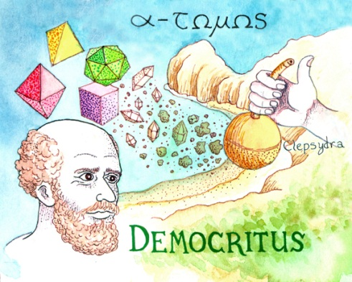

- How did Democritus assign attributes to atoms?
- What was the other component of the universe besides atoms according to Democritus?
- What were the four elements according to Alchemists?
- Where was Democritus born?
- Who was the next important atomic scientist after Democritus?

http://www.nobeliefs.com/atom.htm
http://en.wikipedia.org/wiki/Democritus
http://www.nndb.com/people/790/000087529/
http://craigjm.tripod.com/physics.html

