Chemistry A
Bonding


Worksheet #1: Introduction to Ionic Bonds

The forces that hold matter together are called chemical bonds. There are four major types of bonds. We need to learn in detail about these bonds and how they influence the properties of matter. The four major types of bonds are:
I. Ionic Bonds III. Metallic Bonds
II. Covalent Bonds IV. Intermolecular (van der Waals) forces

Ionic Bonds
The ionic bond is formed by the attraction between oppositely charged ions. Ionic bonds are formed between metals and nonmetals. Remember that metal atoms lose one or more valence electrons in order to achieve a stable electron arrangement. When a metal atom loses electrons it forms a positive ion or cation. When nonmetals react they gain one or more electrons to reach a stable electron arrangement. When a nonmetal atom gains one or more electrons it forms a negative ion or anion. The metal cations donate electrons to the nonmetal anions so they stick together in an ionic compound. This means that ionic bonds are formed by the complete transfer of one or more electrons.

A structure with its particles arranged in a regular repeating pattern is called a crystal. Because opposite charges attract and like charges repel, the ions in an ionic compound stack up in a regular repeating pattern called a crystal lattice. The positive ions are pushed away from other positive ions and attracted to negative ions so this produces a regular arrangement of particles where each ion is surrounded by ions of the opposite charge. Each ion in the crystal has a strong electrical attraction to its oppositely charged neighbors so the whole crystal holds together as one giant unit. We have no individual molecules in ionic compounds, just the regular stacking of positive and negative ions.

- Define the following terms:
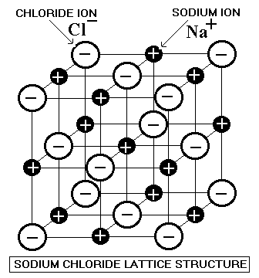
a) ionic bond –

b) cation –

c) anion –

d) crystal –

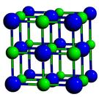
- What are the smallest units of an ionic bond?

At room temperature ionic compounds are high melting point solids. They are usually white except for compounds of the transition metals that may be colored. They are brittle (break easily). They do not conduct electricity as solids, but do conduct electricity when melted or dissolved in water.

- List several properties of ionic compounds:

- When can electricity to be conducted in an ionic bond?

Worksheet #2: Reviewing Lewis Dot Diagrams

Write the Lewis Dot Diagrams for the following:

helium atom:

beryllium atom: beryllium ion:

neon atom:

aluminum atom: aluminum ion:

magnesium atom: magnesium ion:

sodium atom: sodium ion:

Write the Lewis Dot Diagrams for:

oxygen atom: oxide ion:

chlorine atom: chloride ion:

phosphorus atom: phosphide ion:

How would you describe (in general) the Lewis Dot Diagram for:

a) a cation?

b) an anion?

What type of bonding would you expect in a compound that contains a metal and a nonmetal?

Worksheet #3: Drawing Ionic Bonds

Remember: Ionic bonds form between POSITIVE IONS and NEGATIVE IONS. Ionic bonding is when one of the atoms is donating an electron(s) (the cation) and one of atoms is accepting an electron(s) (the anion). The electrons are not shared, the anion gains an electron(s) to achieve a full valence and the cation loses an electron(s) to achieve a full valence.

Diagram the ionic bonding process from neutral atoms to ions showing the valence electrons and indicating with arrows the direction in which the electrons are going. Write your final answer in the box.


Ex: sodium nitride (Na₃N)

- sodium chloride (NaCl) 5. potassium fluoride (KF)

- barium oxide (BaO) 6. sodium oxide (Na₂O)

- magnesium chloride (MgCl₂) 7. aluminum chloride (AlCl₃)

4. calcium chloride (CaCl₂) 8. rubidium oxide (Rb₂O)

Worksheet #4: Introduction to Covalent Bonds

A covalent bond is formed between nonmetal atoms. The nonmetals are connected by a shared pair of valence electrons. Remember, nonmetals want to gain valence electrons to reach a stable arrangement. If there are no metal atoms around to give them electrons, nonmetal atoms share their valence electrons with other nonmetal atoms. Since the two atoms are using the same electrons they are stuck to each other in a neutral particle called a molecule. A molecule is a neutral particle of two or more atoms bonded to each other. Molecules may contain atoms of the same element such as N₂, O₂, and Cl₂ or they may contain atoms of different elements like H₂O, NH₃, or C₆H₁₂O₆. Therefore, covalent bonding is found in nonmetallic elements and in nonmetallic compounds.

Covalent bonds are intramolecular forces; that is, they are inside the molecule and hold the atoms together to make the molecule. Covalent bonds are strong bonds and it is difficult and requires a lot of energy to break a molecule apart into its atoms. However, since molecules are neutral one molecule does not have a strong electrical attraction for another molecule. The attractions between molecules are called intermolecular forces and these are weak forces.

Covalent substances have low melting points and boiling points compared to ionic compounds or metals. At room temperature, covalent substances are gases, liquids or low melting point solids. They do not conduct electricity as solids or when molten and usually do not conduct when dissolved in water.

1. Define the following terms:
a) covalent bond –

b) molecule –

c) intramolecular force–

d) intermolecular force–

2. List several properties of covalent compounds.

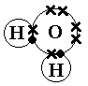
There are many types of covalent bonds. A single covalent bond is when two atoms share one pair of valence electrons (see figure). A double covalent bond is when two atoms share two pairs of valence electrons. A triple covalent bond is when two atoms share three pairs of valence electrons.

3. Define the following terms:

a) single covalent –

b) double covalent –

c) triple covalent –

There is one last type of covalent bonding—the bonding in network solids (macromolecules). In this type of bonding, atoms share valence electrons but the atoms are arranged in a regular crystalline pattern in which each atom is covalently bonded to its neighbors in all directions. Therefore, you do not have a collection of small molecules that are easy to separate from each other; the whole system is one giant molecule or a macromolecule held together by this network of strong covalent bonds. Network solids are extremely hard, brittle, solids that do not conduct electricity. Diamonds (a form of pure carbon (see figure)), carborundum (silicon carbide) and quartz (silicon dioxide) are examples of macromolecules.

- What is a network solid?
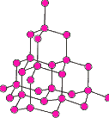

- What type of bonding exists in network solids?

- What are some properties of network solids?

- What are some examples of network solids?

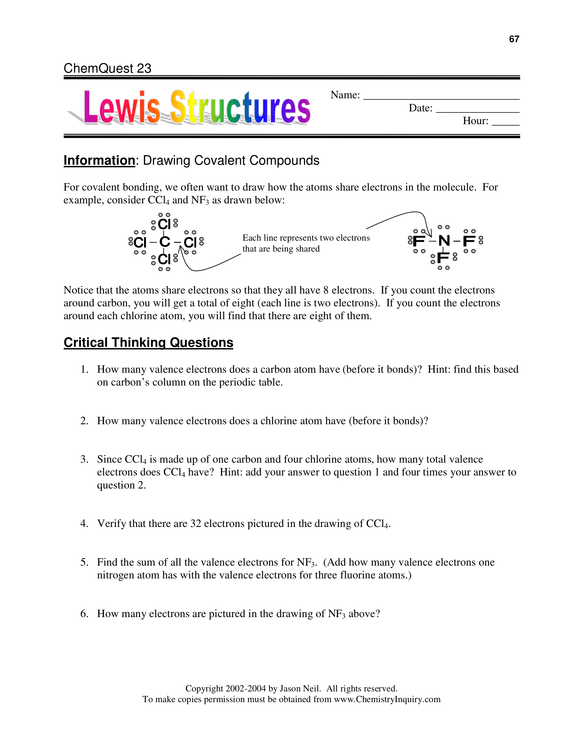
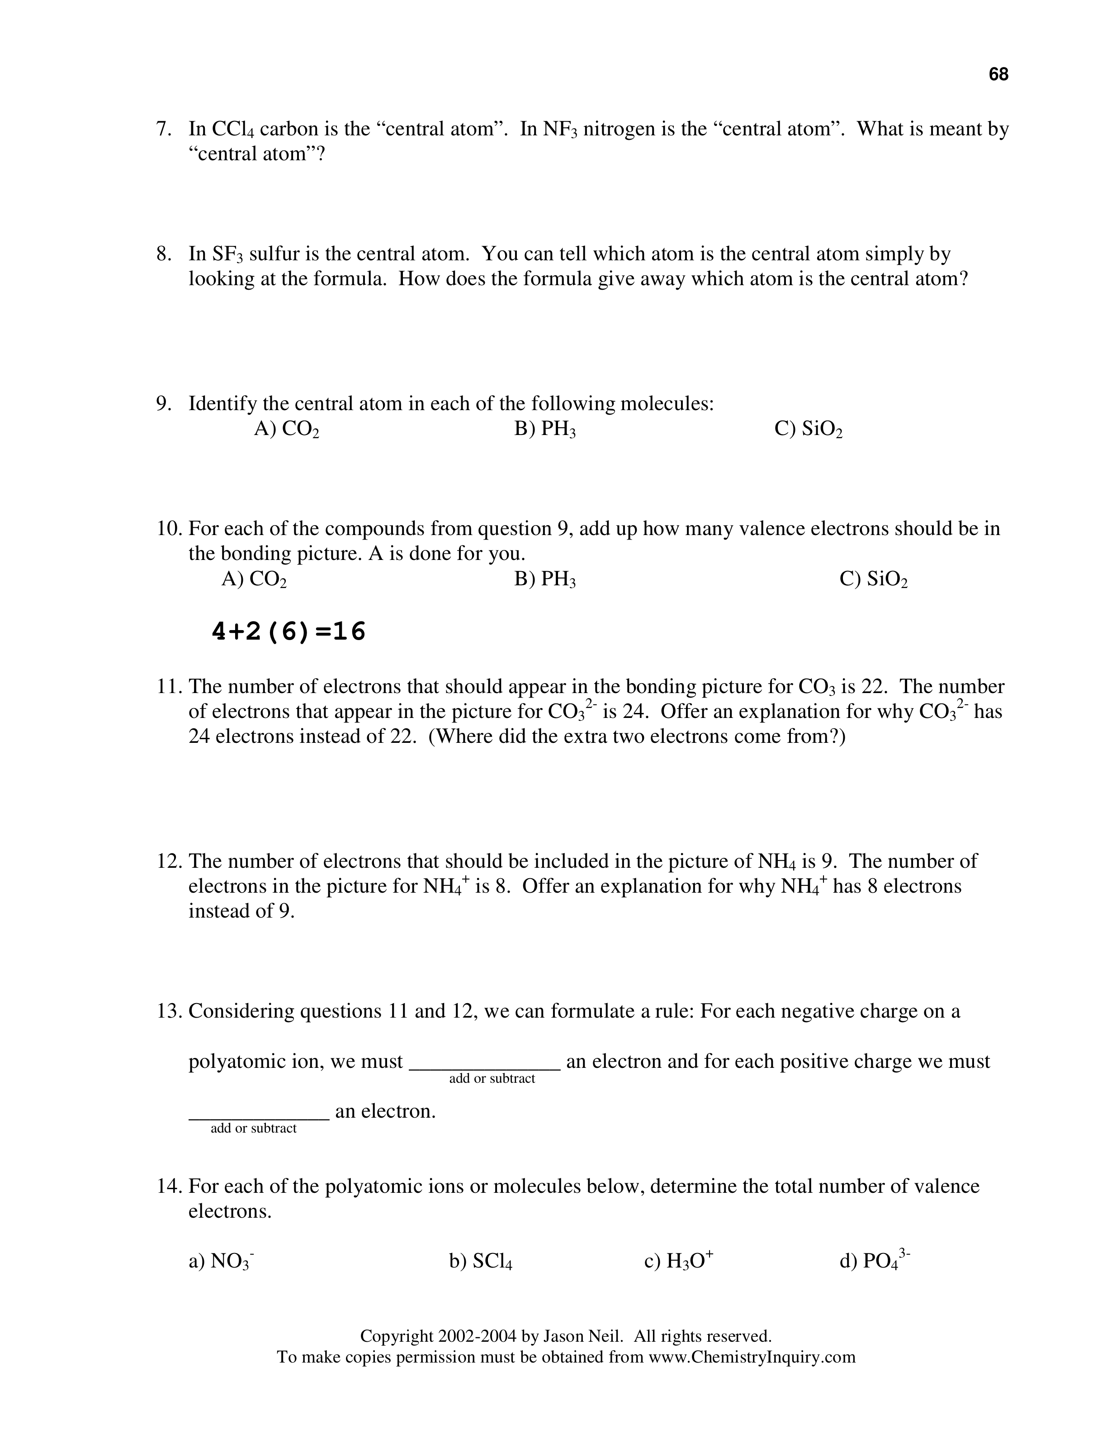
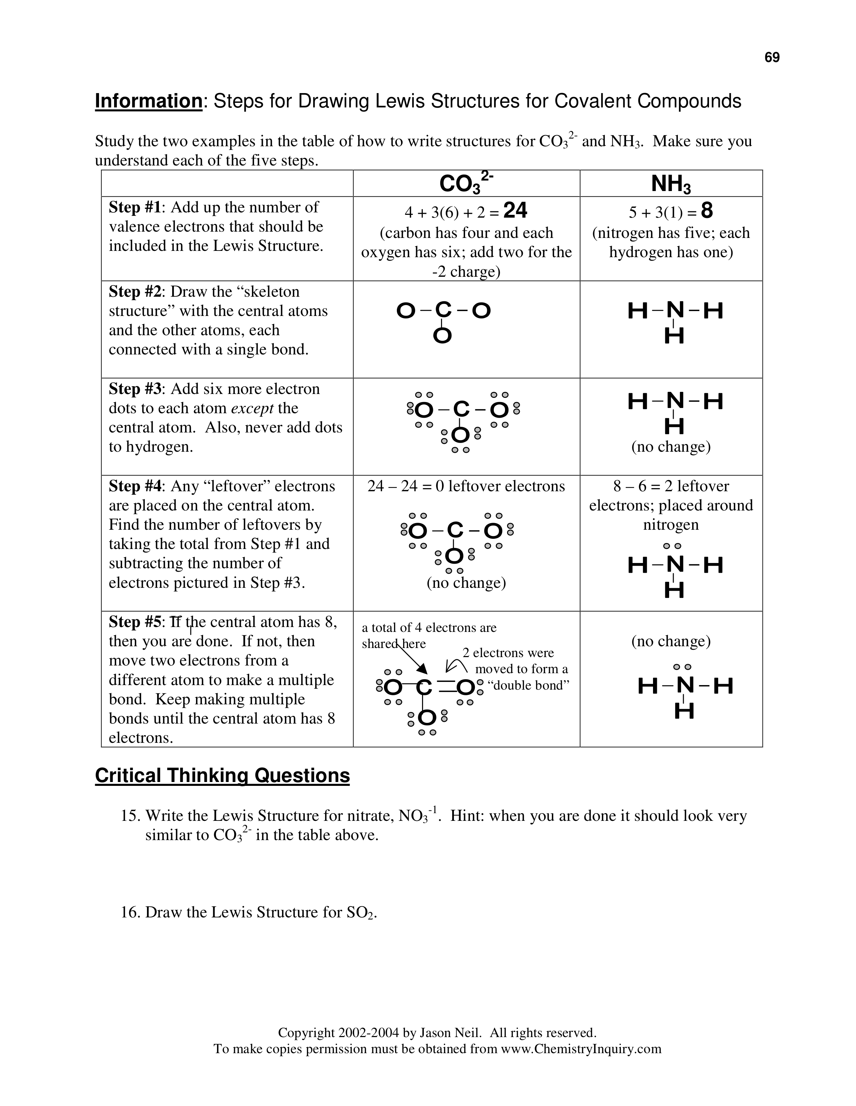
Worksheet #5: Drawing Single Covalent Bonds

Background info:
When atoms of nonmetals bond to each other they share valence electrons and form a covalent bond. When atoms bond they usually have to rearrange their electrons from the positions we pictured in the single atom. The goal is for every atom to have eight electrons around it except for hydrogen which has only two electrons. Hydrogen only forms one single bond; other atoms can form up to four single bonds. When you draw a dot diagram for a molecule you start with the atom that is only in the formula once—it will be in the center of the molecule with the other atoms arranged around it. If there are only two atoms it doesn’t matter where you start. Draw Lewis dot diagrams for the following molecules.

HINT: Carbon, nitrogen, and sulfur are usually the central atom(s) (in the center) surrounded by terminal atoms (surrounding central). Carbon is always a central and hydrogen is always a terminal. When in doubt, put the any single atom in the middle, surrounding it with the element that contains more than one atom.
Final Answer
Ex: nitrogen triiodide (NI₃)
Show work here

- carbon tetrabromide (CBr₄)

- dihydrogen monosulfide (H₂O)

- dihydrogen monoselenide (H₂Se)

4. phosphorus triodide (PI₃)

Worksheet #5 Continued

1. Draw the single bonds below.
a) hydrogen (H₂) b) bromine (Br₂)

c) water (H₂O) d) ammonia (NH₃)

2. Review of WS#1 and WS#2. Determine if it is an ionic bond or a covalent bond. Show the work and the final answer
Remember: Covalent bonds form between two nonmetals that share electrons. Ionic bonds are formed between a metal and a nonmetal that completely transfer electrons.
e) methane (CH₄) f) iron (II) oxide (FeO)

g) carbon tetrachloride (CCl₄) h) phosphorus tribromide (PBr₃)

i) sodium nitride (Na₃N) j) hydrochloric acid (HCl)

Worksheet #6: Double AND Triple Bonds

Double bonds can form when a shared single bond alone doesn’t satisfy either atoms valence. Double bonds are TWO SHARED PAIRs of electrons for a total of 4 electrons (2 electrons from one atom and 2 from the other). Double bonds are much stronger and bond the atoms closer than a single bond.

Ex: carbon dioxide
Show work here. Final Answer

- oxygen (O₂)

- ethene (C₂H₄)*** C’s are always central and they will link together.

Triple bonds can form when 3 pairs of electrons are shared for a total of 6 shared electrons. Typically one atom donates 3 electrons and the other atom donates the other 3. Triple bonds are even stronger than double bonds and the atoms are held even closer together.

EX: nitrogen (N₂)

3. ethyne (C₂H₂) (remember C's are always central atoms)

Worksheet #6 Continued

We have looked at diagrams for ionic compounds and for molecules of covalent substances that contain only single bonds. Many molecules contain double or triple bonds. Ideally an atom is involved in only single bonding that is a more stable arrangement. But, if the atom cannot achieve eight electrons in its valence shell it will become involved in double or triple bonds to reach this stable arrangement. Draw diagrams for the following molecules.

1. Double Bonds:
a) oxygen (O₂) b). formaldehyde (H₂CO) * the C’s in the middle attach the
2 Hs and the O to it.

2. Triple Bonds:
c) nitrogen (N₂) d). hydrogen cyanide (HCN) *the carbon is in the middle with
the other two attached to it.

3. A mixture of all types of bonds: RECALL THE DIFFERENCE BETWEEN IONIC AND COVALENT!!!
e) N₂H₂ *** (N goes in the middle) f) C₂H₆ *** (C’s in the middle)

g) CF₂Cl₂ *** (C in the middle, 2 F’s and Cl’s around it) h) KF

i) N₂F₄ *** (N’s in the middle) j) Mg₃N₂

Worksheet #7: Polyatomic Ions and Coordinate Covalent Bonding

Now you are going to draw electron dot diagrams for the following polyatomic ions. Remember that even though they are ions the atoms are held together inside the ion with covalent bonds. Negative ions have gained electrons, you must include these in the structure. Positive ions have lost electrons, you must delete these from the structure.

Ex: ammonium ion [NH₄]⁺¹ Final Answer

- hydroxide ion [OH]⁻¹

A coordinate covalent bond is when both of the electrons shared in the bond originally belonged to one of the atoms—the other atom is just mooching. This coordinate covalent bond doesn’t behave any differently than other single bonds—it just is different in the way it was formed. In the following polyatomic ions, oxygen is mooching electrons from other atoms.

Ex: bromate ion [BrO₃]⁻¹

2. phosphite ion [PO₃]⁻³

3. perchlorate ion [ClO₄]⁻¹

Worksheet #8: Polarity and Electronegativity

When atoms share valence electrons they do not always share them equally. Frequently one atom has a stronger attraction for the electrons than the other atom does. This uneven attraction causes the electrons to be held closer to one end of the bond than the other; we say this makes one end of the bond slightly positive and the other end of the bond slightly negative. A covalent bond with uneven sharing of the electrons is called a polar covalent bond. A bond in which the electrons are shared equally is called a nonpolar covalent bond.

1. Define the following terms:

a. polar covalent

b. nonpolar covalent

Electronegativity is a measure of the ability of an atom of an element to attract electrons to itself. Put another way, electronegativity is a measure of the force of attraction that exists between an atom and a shared pair of electrons in a covalent bond. Linus Pauling developed a scale of electronegativities that run from a low of 0.7 for several metals in Group I to a high of 4.0 for fluorine.
The table below gives Pauling Values for Electronegativity:
H  2.1 |  |  |  |  |  |  |  |  |  |  |  |  |  |  |  |  | He  ….
Li  1.0 | Be  1.5 |  |  |  |  |  |  |  |  |  |  | B  2.0 | C  2.5 | N  3.0 | O  3.5 | F  4.0 | Ne  ….
Na  0.9 | Mg  1.2 |  |  |  |  |  |  |  |  |  |  | Al  1.5 | Si  1.8 | P  2.1 | S  2.5 | Cl  3.0 | Ar  ….
K  0.8 | Ca  1.0 | Sc  1.3 | Ti  1.5 | V  1.6 | Cr  1.6 | Mn  1.5 | Fe  1.8 | Co  1.8 | Ni  1.8 | Cu  1.9 | Zn  1.6 | Ga  1.6 | Ge  1.8 | As  2.0 | Se  2.4 | Br  2.8 | Kr  ….
Rb  0.8 | Sr  1.0 | Y  1.2 | Zr  1.4 | Nb  1.6 | Mo  1.8 | Tc  1.9 | Ru  2.2 | Rh  2.2 | Pd  2.2 | Ag  1.9 | Cd  1.7 | In  1.7 | Sn  1.8 | Sb  1.9 | Te  2.1 | I  2.5 | Xe  ….
Cs  0.7 | Ba  0.9 | La-Lu  1.1-1.2 | Hf  1.3 | Ta  1.5 | W  1.7 | Re  1.9 | Os  2.2 | Ir  2.2 | Pt  2.2 | Au  2.4 | Hg  1.9 | Tl  1.8 | Pb  1.8 | Bi  1.9 | Po  2.0 | At  2.2 | Rn  ….
Fr  0.7 | Ra  0.9 | Ac-Lr  1.1-
We use electronegativity values when we discuss bond polarity. If two atoms sharing a pair of electrons have equal values for electronegativity the bond is clearly nonpolar. As the difference in electronegativity increases the polarity of the bond increases, and if the difference in electronegativity is very large the bond is ionic.
2. What is electronegativity?

- Sodium chloride (NaCl) is an example of an ionic bond. What is the difference in electronegativity between sodium and chlorine?

- Nitrogen dioxide (NO₂) is an example of a covalent bond. What is the difference in electronegativity between nitrogen and oxygen?
It is difficult to decide exactly what we consider nonpolar, polar or ionic since bonds may have some covalent character and some ionic character. For convenience for beginning students we have established some arbitrary guidelines:
ELECTRONEGATIVITY VALUES OF THE ELEMENTS, ACCORDING TO THE PERIODIC TABLE
Difference in electronegativity Intramolecular Bond Type
0------.49 nonpolar covalent
.5------1.69 polar covalent
1.7 or greater ionic

Use the table and chart from this worksheet to label the following compounds as nonpolar, polar or ionic:

a. NH₃

b. MgO

c. Cl₂

d. HCl
e.H₂O

f. NaCl

g. CH₄

h. NO₂

Worksheet #9: Intermolecular (van der Waals) Forces

Van der Waals Forces are intermolecular forces; that is, they are attractions between neutral molecules. They hold molecules together to make liquids or solids. They are the forces we break when we melt or boil a substance. All van der Waals forces are weak compared to ionic bonds, covalent bonds, and metallic bonds. However, there is a wide range of strength in van der Waals forces depending upon the type of molecules they are holding together. There are dipole-dipole interactions and hydrogen bonds, which hold polar molecules to other polar molecules and are the strongest of the van der Waals forces. There are London forces, which hold nonpolar molecules to other nonpolar molecules and are the weaker type of van der Waals forces.
Polar molecules (or dipoles) are molecules that do not have an even distribution of electrical charge. One end of the molecule is partially positive, the other end partially negative. The partially positive end of one molecule is attracted to the partially negative end of another molecule. These attractions between polar molecules are called dipole-dipole interactions. Hydrogen bonds are a special kind of dipole-dipole interaction where the partially positive end of a molecule contains a hydrogen atom. Dipole-dipole interactions and hydrogen-bonds are the strongest types of van der Waals forces. Water is a compound that is considered the classic example of a substance containing hydrogen bonding. It is those hydrogen bonds that we are breaking when we melt or boil water.
There are weak attractions that exist between nonpolar molecules; we know this because many substances that are made of nonpolar molecules are liquids or low melting point solids. If there were no attractions between the molecules they would fly apart and the substance would be a gas. The weak attractions between nonpolar molecules are called London forces and they are the weakest of the van der Waals forces. They are extremely weak so nonpolar covalent substances are frequently gases as room temperature. We believe that London forces or dispersion forces are the result of the weak, momentary attractions called instantaneous dipoles. An instantaneous dipole is formed when electrons moving in a molecule get “off balance” for an instant so for that instant one end of the molecule is positive and the other end is negative. This will cause charges in the neighboring molecules and set up a whole chain reaction of short-lived attractions. As the electrons continue to move the charges even out again but the whole process happens many times per second in a sample of matter containing billions of molecules.

4. What are van der Waals forces?

5. What is a dipole?

6. What is a dipole-dipole force/interaction?

7. What is a hydrogen bond?

8. What are London forces?

9. Explain instantaneous dipoles.

Worksheet #9 Continued
Now that we know about intermolecular forces, we can expand the table from the previous worksheet:
Difference in electronegativity  (BIG – small) | Intramolecular Forces  (within ONE molecule) | Intermolecular Forces  (between MULTIPLE molecules) | Examples
0 - 0.49 | Nonpolar Covalent  (electrons are SHARED EQUALLY) | London Forces | O₂
0.5 – 1.69 | Polar Covalent  (electrons are SHARED UNEQUALLY) | 1. Hydrogen Bonding (any polar molecules WITH HYDROGEN)  2. Dipole-Dipole (any polar molecule WITHOUT HYDROGEN) | H₂O
1.7 or greater | Ionic  (electrons are TRANSFERRED) | Ionic  (positive ions are attracted to negative ions) | NaCl
Use your electronegatvity table and the chart above to answer the following questions:

1. Determine the INTRAmolecular force for the following compounds: (nonpolar covalent, polar covalent, ionic)

CH₄ = ______________ CF₄= ______________ HI = ________________

CO₂ = ______________ NH₃= ______________ NaCl = _______________

2. How did you determine the intramolecular force for these compounds?

3. Determine the INTERmolecular force for the compounds above: (London forces, dipole-dipole, H bonding, ionic)

CH₄ = ______________ CF₄= ______________ HI = ________________

CO₂ = ______________ NH₃= ______________ NaCl = _______________

4. How did you determine the intermolecular force for these compounds?
Worksheet #10: Metallic Bonds

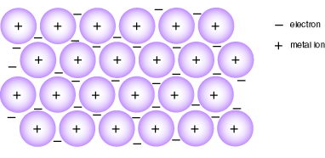
A metallic bond forms between multiple metal atoms. The metallic bond is formed by the mutual attraction for each others loosely held valence electrons. Most metal atoms have only one or two valence electrons and these are not tightly bound to the atoms. In a piece of metal these valence electrons do not seem to belong to any one of the atoms but are able to move freely through the structure from one atom to another. Metals can be thought of as positive ions (the nucleus and inner shells of electrons—all of the atom except the valence electrons) in a “sea” of loose valence electrons. The metal ions line up in a regular repeating pattern (a crystal lattice) and their loose valence electrons move through this crystal acting as an electron glue (see figure). Each of the ions is strongly attracted to all of the loose electrons surrounding it so the whole metal holds together as a crystal.
These electrical attractions for the electron glue are strong and hard to break so metals are high melting point crystalline solids. Since there are charged particles free to move metals are good conductors of heat and electricity as solids and as liquids. Because the “electron glue” is free to move, if we hammer or pull the cations to new positions the electron glue flows right along with the cations and holds the structure together in the new position. Thus, metals are malleable (bendable) and ductile (can be hammered flat) and have a high tensile strength (can be stretched without breaking). This loose cloud of electrons is good at absorbing and re-emitting the light energy that strikes it so metals are lustrous (shiny).

Metallic bonding is found in elemental metals and in mixtures of metals called alloys.
1. What is a metallic bond? Explain how the ions and electrons are arranged.

2. List some properties of metallic bonds.

3. What is an alloy?

4. Identify the following compounds as metallic, ionic or covalent:

- NaCl
- Cl₂
- Au
- [BrO₃]⁻¹
- Mg₃N₂
- Pt
- Al

h. Ag

Worksheet #11: Bonding Vocabulary Review Sheet
Give the type of bond or force described by the following:
Your choices can be (and you will use some them more than once):
Covalent Metallic Bond Network Solid
Ionic bond Van der Waals (Intermolecular)

_________________________ 1. This bonding is found between cations and anions.

_________________________ 2. This is found between atoms of nonmetals.

_________________________ 3. This is found between atoms of metals.

_________________________ 4. This is the force that holds quartz together.

_________________________ 5 This is a term to describe all intermolecular forces.

_________________________ 6. This is the force that produces electrical conductivity in the solid state.

_________________________ 7. This is the force that produces an electrical insulator in the solid state but an electrical conductor in the liquid state.

_________________________ 8. This is the force that holds crystals of table salt together.

_________________________ 9. This is the force that holds a diamond together.

Your choices can be (and you will use some them more than once):
Polar Covalent Hydrogen Bond London Force
Nonpolar Covalent Dipole-Dipole Force Ionic Bond

_________________________ 10. This is the term to describe the attraction between one polar molecule and another polar molecule.

_________________________ 11. This is the term to describe the attraction between one nonpolar molecule and another nonpolar molecule.

_________________________ 12. This is the force inside a molecule of bromine (holds the molecule together).

_________________________ 13. This is the force between two molecules of bromine (holds molecules together).

_________________________ 14. This is the force inside a molecule of methane CH₄.

_________________________ 15. This is the force between two molecules of methane CH₄.

_________________________ 16. This is the force that holds cesium fluoride together.

_________________________ 17. This is the force that holds the carbon to the oxygen in carbon dioxide.

_________________________ 18. This is the force inside a water molecule (H₂O)

_________________________ 19. This is the force between water molecules.

_________________________ 20. This is the force inside a molecule of nitrogen (N₂).

_________________________ 21. This is the force between two molecules of nitrogen.

Worksheet #12: Bonding Pictures Review Sheet

Draw Lewis dot diagrams for the following compounds.

Remember that you must check the difference in electronegativity—if the difference is less than 1.7 draw a covalent structure and if the difference is 1.7 or greater draw an ionic structure.

a) water (H₂O) b) potassium iodide (KI)

c) nitrogen molecule (N₂) d) ammonia (NH₃)

e) calcium iodide (CaI₂) f) phosphorous trichloride (PI₃)

g) aluminum fluoride (AlF₃) h) carbon dioxide (CO₂)

i) oxygen molecule (O₂) j) magnesium nitride (Mg₃N₂)

Worksheet #12 Continued

k) chlorine molecule (Cl₂) l) ethane (C₂H₆) (carbons hook to each other with H’s all around)

m) hydroxide ion [OH]⁻¹ n) sulfite ion [SO₂]⁻²

o) ammonium ion [NH₄]⁺¹ p) sodium oxide (Na₂O)

q) sulfate ion [SO₄]⁻² r) calcium bromide (CaBr₂)

s) methane (CH₄) t) sulfur dioxide (SO₂)

Worksheet #13: Bonding Multiple Choice Review Sheet
For questions 1-30 the choices are:
(1) ionic (2) polar covalent (3) nonpolar covalent (4) metallic (5) van der Waals forces
*** If you use this, be specific on
1. The bonding found in calcium chloride is … WHICH van der Waals force.

2. The bonding found in silver is …

3. The bonding found inside a molecule of carbon tetrachloride is …

4. The bonding that holds water molecules together to make ice is …

5. The bonding found in a white, high melting point crystalline solid that conducts electricity when liquid…

6. The bonding found in diamonds is …

7. The bonding found between atoms in carbon disulfide is …

8. The bonding found in a molecule of bromine is …

9. The bonding found in a molecule of ammonia (NH₃) is …

10. The intramolecular force in iodine (I₂) is …

11. The intermolecular force in iodine is …

12. The bonding found is sodium fluoride is …

13. The bonding that produces electrical conductivity in the solid state is …

14. The bonding that exists between two O₂ molecules is …

15. The bonding found in a network solid is either … or …

16. The bonding found in any alloy is …

17. The bonding that includes dipole-dipole interaction is …

18. The bonding that results from the complete transfer of electrons is …

19. The bonding that is an equal sharing of valence electrons is …

20. The bonding between elements with an electronegativity difference of 1.75 is …

21. The bonding in calcium oxide is …

22. The bonding within a sulfate ion is …

23. The bonding between sodium and sulfate in sodium sulfate is …

24. The bonding within hydrocarbon molecules (made of hydrogen and carbon) is …

25. The bonding between hydrocarbon molecules is …

26. The bonding that depends upon a loose cloud of valence electrons or an “electron glue” is …

27. The bonding that creates dipoles is …

28. The bonding between dipoles is …

For questions 31-50 the choices are:
(1) single covalent (2) double covalent (3) triple covalent (4) hydrogen bonding (5) London forces

29. The bonding that results from the formation of “instantaneous dipoles” is …

30. The intramolecular forces in liquid nitrogen (N₂) are …

31. The intermolecular forces in liquid nitrogen are …

32. The intramolecular forces in water are …

33. The intermolecular forces in water are …

34. The bonding found in the cyanide ion [CN]⁻¹ is …

35. Acetylene (C₂H₂) has the carbons bonded to each other and one hydrogen bonded to each carbon. The bonding between the carbon atoms is …

36. The attraction of a hydrogen atom in one molecule for a more electronegative element in another molecule is what we call …

37. The bonding that is synonymous with dispersion forces is …

38. The strongest of the above choices is …

39. The weakest of the above choices is …

40. The bonding that involves two atoms sharing three pairs of electrons is …

41. The bonding that is broken when you turn water into steam is …

42. The bonding that is broken when you do electrolysis (splitting) of water molecules to form hydrogen and oxygen is …

43. The bonding in a molecule of carbon dioxide is …

44. The bonding between molecules of ozone (O₃) is …

45. The intramolecular force in hydrogen chloride is …

46. The intramolecular force in carbon monoxide is …

ANSWERS
1. (1) 2. (4) 3. (2) 4. (5) 5. (1) 6. (3) 7. (3) 8. (3) 9. (2) 10. (3) 11. (5) 12. (1)
13. (4) 14. (5) 15. (2) or (3) 16. (4) 17. (5) 18. (1) 19. (3) 20. (1) 21. (1) 22. (2) 23. (1)
24. (3) 25. (5) 26. (4) 27. (2) 28. (5) 29. (5) 30. (3) 31. (5) 32. (1) 33. (4) 34. (3) 35. (3)
36. (4) 37. (5) 38. (3) 39. (5) 40. (3) 41. (4) 42. (1) 43. (2) 44. (5) 45. (1) 46. (3)

