The Bohr Model of the Atom
By Ethan, JV, Jonty, and Eric
- Niels Henrick David Bohr was born on October 7, 1885 in Copenhagen.
- He grew up with his father.
- His father was known for being intelligent.
- He was an eminent physiologist.
- He entered Copenhagen University in 1902.
- Bohr took his Master’s degree in physics in 1909. 2 years later, he took his Doctor’s degree.
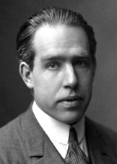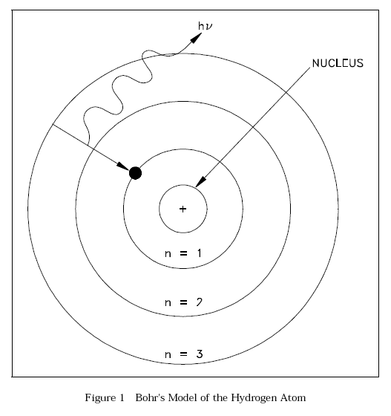

Bohr Model
The Bohr model was first introduced by Niels Bohr in 1913. The Bohr model is a model for the atom that has a positive charged nucleus in the middle. The nucleus is surrounded by electrons that orbit around it. The energy of the orbit is related to its size. The lowest energy is found in the smallest orbit. Radiation is absorbed or emitted when an electron moves from one orbit to another. This model of the atom proposes that electrons orbit a nucleus at a predetermined distance. Bohr believed that each orbit was defined by certain energy, so he said that the distance of electrons from the nucleus was determined by their energy.
Problems with the Bohr Model

- It violates the Heisenberg Uncertainty Principle because it considers electrons to have both a known radius and orbit.
- The Bohr Model provides an incorrect value for the ground state orbital angular momentum.
- It makes poor predictions regarding the spectra of larger atoms.
- It does not predict the relative intensities of spectral lines.
- The Bohr Model does not explain fine structure and hyperfine structure in spectral lines.
- It does not explain the Zeeman Effect.

