Biological Pigments



* Coloured compounds produced in living organisms
* Generally have extensive systems of alternating _________________ and __________________ carbon-carbon bonds



* Overlapping ___ electron clouds result in __________________ electrons (conjugation)



* Larger conjugated systems typically absorb light of lower energy (________________ wavelength)



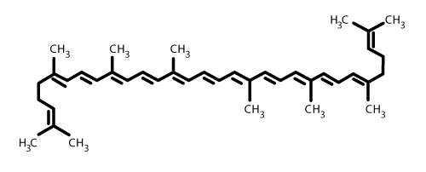Examples:



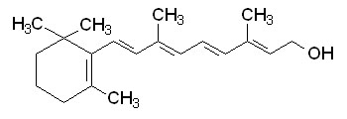



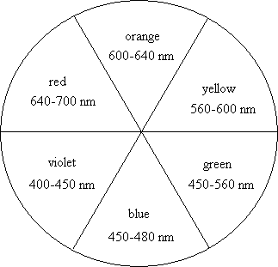



* Colour we see is complementary (across the colour wheel) from the wavelength of light the pigment absorbs.



* Carotenes such as retinol and lycopene are fat soluble. Why might you expect this?



* Carotenes also play a role as anti-oxidants in living organisms



Porphyrins



* Complexes of metal ions with cyclic ligands



* Porphin – contains four nitrogen atoms in a conjugated heterocycle
* Nitrogen atoms in porphyrin bind to ________________ ions, forming very stable chelate complexes.



* Iron complexes of porphyrins = _____________________



* + Examples:



Hemoglobin

* Main oxygen transport protein in higher animals
* Made up of ________________ subunits



* Each subunit binds ______________ oxygen molecule



* Cooperative binding



* + According to induced fit model, binding of _________________ to deoxygenated heme changes _____________________of the whole molecule, thus increasing ______________________________ of the molecule for oxygen



* 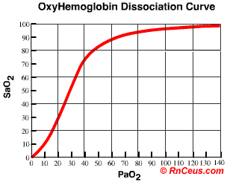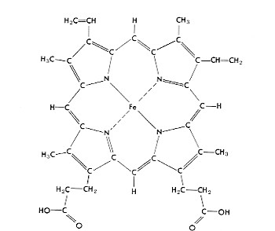



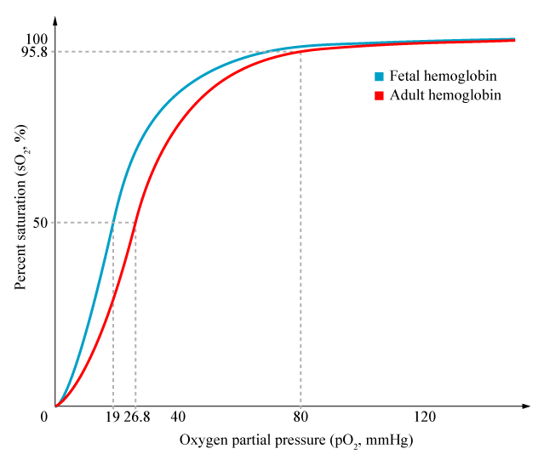



* Carbon monoxide is a ____________________________ inhibitor.



* + Why?



* + Predict the shape of the saturation curve in the presence of carbon monoxide.



Cytochromes –enzymes containing heme groups



* During redox reactions, iron ions in the heme groups convert back and forth between their ____ and _______ oxidation state (for example cellular repiration)



* Energy from cellular respiration is stored as ATP

**Chlorophyll**

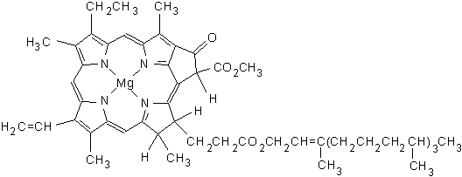



* Absorbs light energy in the visible region of the UV spectrum



* Ultimately, energy is passed through a series of intermediates in the ________________ transport chain and results in the oxidation of water to oxygen and protons



* Protons produced are used in the synthesis of ATP
* Chlorophyll absorbs in the blue and red regions of the spectrum

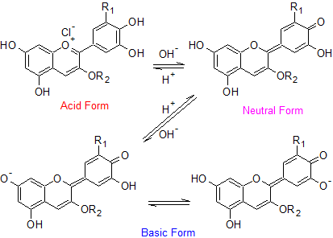**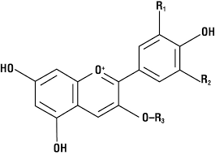Anthocyanins**

