Biological Pigments
- Coloured compounds produced in living organisms
- Generally have extensive systems of alternating _________________ and __________________ carbon-carbon bonds
- Overlapping ___ electron clouds result in __________________ electrons (conjugation)
- Larger conjugated systems typically absorb light of lower energy (________________ wavelength)
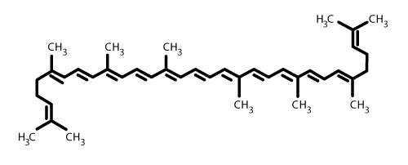
Examples:

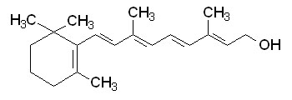

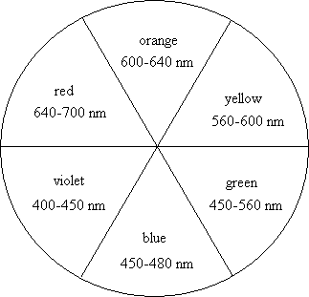

- Colour we see is complementary (across the colour wheel) from the wavelength of light the pigment absorbs.
- Carotenes such as retinol and lycopene are fat soluble. Why might you expect this?

- Carotenes also play a role as anti-oxidants in living organisms

Porphyrins
- Complexes of metal ions with cyclic ligands
- Porphin – contains four nitrogen atoms in a conjugated heterocycle
- Nitrogen atoms in porphyrin bind to ________________ ions, forming very stable chelate complexes.
- Iron complexes of porphyrins = _____________________
  - Examples:
Hemoglobin
- Main oxygen transport protein in higher animals
- Made up of ________________ subunits
- Each subunit binds ______________ oxygen molecule
- Cooperative binding
  - According to induced fit model, binding of _________________ to deoxygenated heme changes _____________________of the whole molecule, thus increasing ______________________________ of the molecule for oxygen
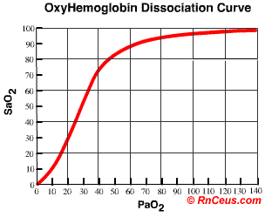
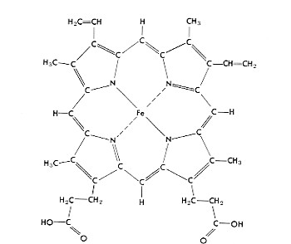

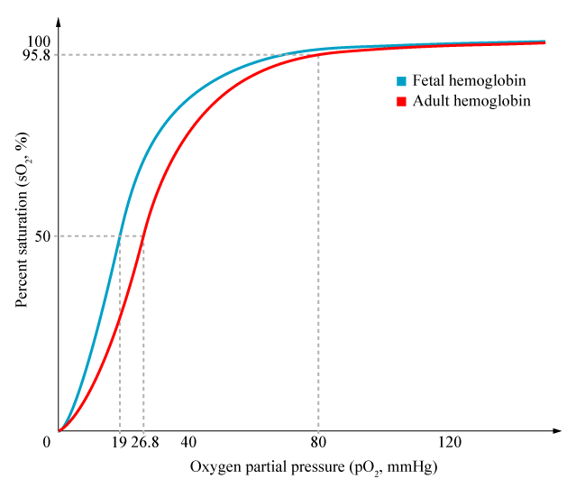
- Carbon monoxide is a ____________________________ inhibitor.
  - Why?

  - Predict the shape of the saturation curve in the presence of carbon monoxide.

Cytochromes –enzymes containing heme groups
- During redox reactions, iron ions in the heme groups convert back and forth between their ____ and _______ oxidation state (for example cellular repiration)
- Energy from cellular respiration is stored as ATP

Chlorophyll
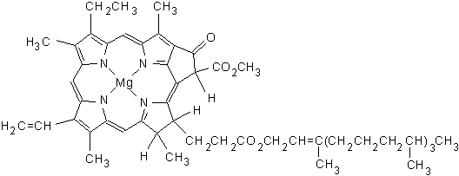
- Absorbs light energy in the visible region of the UV spectrum
- Ultimately, energy is passed through a series of intermediates in the ________________ transport chain and results in the oxidation of water to oxygen and protons

- Protons produced are used in the synthesis of ATP

- Chlorophyll absorbs in the blue and red regions of the spectrum

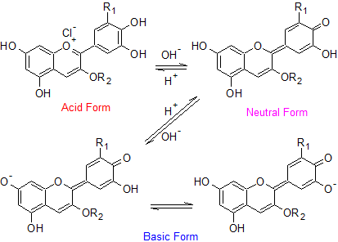
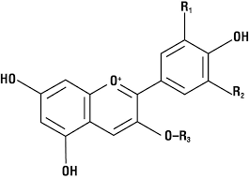
Anthocyanins

