9.2 Electrochemical Cells
Electrochemical cells involve the interconversion of electrical and chemical energy. They fall into two categories:
- Voltaic/galvanic cells – convert ______________ energy to ____________ energy
- Involve ____________________ processes
- Electrolytic cells – convert ___________________ energy to _________________ energy
- Involve ______________________ processes
Electrodes – an electrical conductor used to make contact with the non-metallic part (often solution) of an electrochemical cell.
Anode – electrode at which ___________________ occurs
Cathode – electrode at which ___________________ occurs
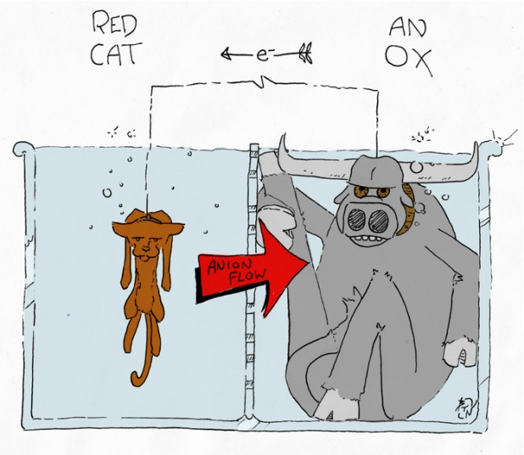
Voltaic Cells:
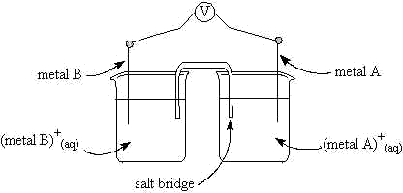

Daniell voltaic cell:
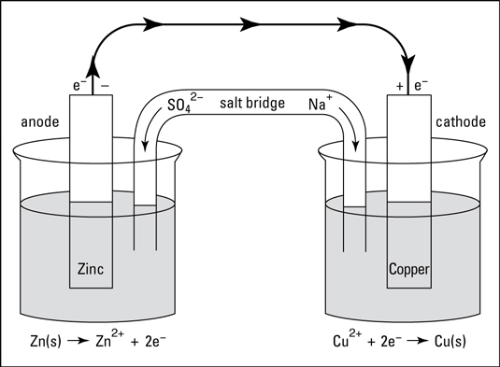
Cell diagrams/Cell notation
Shorthand used to represent the components of an electrochemical cell without drawing a full diagram.
Write the cell diagram for the Daniell cell above:

Electrolytic cell – a non-spontaneous process is driven by the use of electrical energy (an external battery). The process that occurs is called electrolysis.
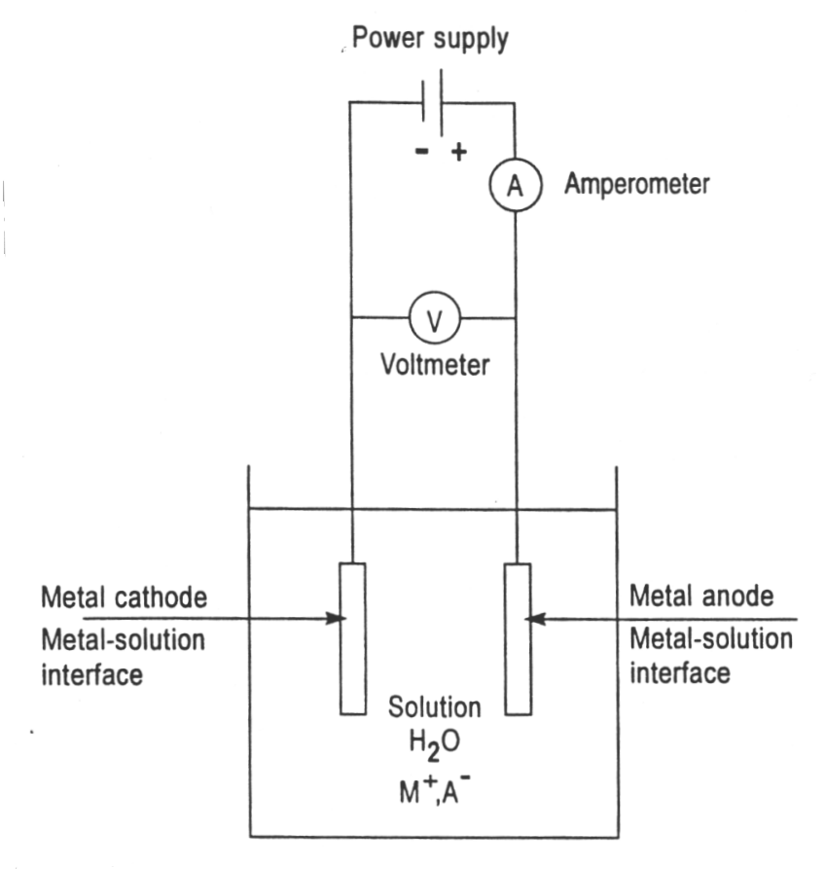
Types of electrolytic cells:
- Electrolysis of molten salt (electrolyte is a LIQUID)
- Electrolysis of aqueous salt (electrolyte is dissolved in water)
In SL, you are only expected to know about electrolysis of molten salts with inert electrodes.
Example: Complete the diagram of an electrolytic cell for molten sodium chloride. Determine the reaction happening at each electrode, the direction of electron flow in the wire, and the charge of each electrode. State what you would observe at each electrode.

