Chapter 13 – The universe and its stars
13.1 – The origin of the Universe
Hubble space telescope is named after ____________________________________________
Edwin Hubble is known for two major discoveries
a)
b)
Evidence for an expanding Universe
a) Red shift
light from galaxies appears to be shifted towards the red end of the spectrum
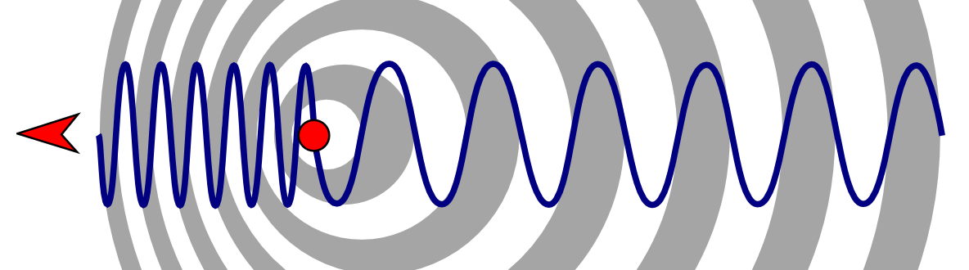
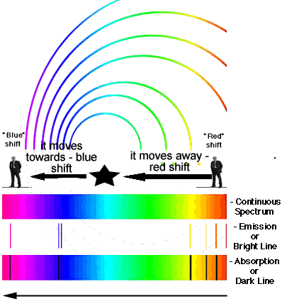
Picture from:
http://www.arm.gov/news/blog/post/18689 (above)
http://www.cyberphysics.co.uk/topics/space/redshift.htm (left)
b) Background Radiation
- 1965 – researchers used __________________________ antenna and found radiation coming from all directions
- Today this is believed to be a remnant of the __________________________
- The radiation is believed to have a temperature of ______________C and correspond to an age of _______ billion years
- Further evidence was gathered by the COBE ( Cosmic __________________________ __________________________) and WMAP (Wilkinson Microwave Anisotropy Probe)
- COBE and WMAP provide evidence that supports the __________________________ ______________________________________________
- Scientists can now pinpoint when and where stars and galaxies formed based on the differences in radiation temperature and density shown by COBE and WMAP
- The universe is believed to be about ________________ billion years old

